Code for printing n Fibonacci numbers:

In this program, we come across a small problem of logical error. The previously written code was returning a wrong output, but was syntactically and semantically fine, so it executed without any error. Using GDB, we came across the line that was causing the logical error, and then we corrected the error to rectify the output of the program.

Below attached are the screenshots of the code before and after error removal:

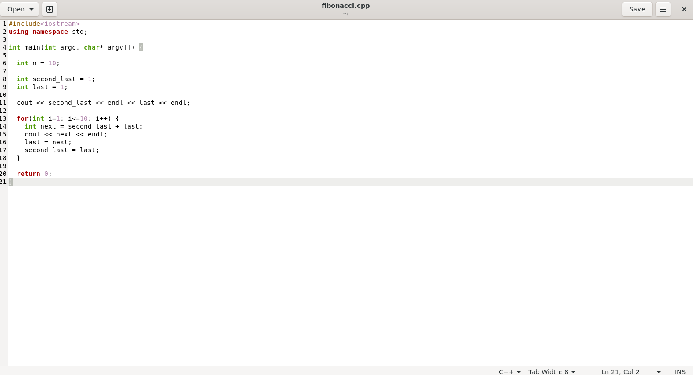

Original code with error

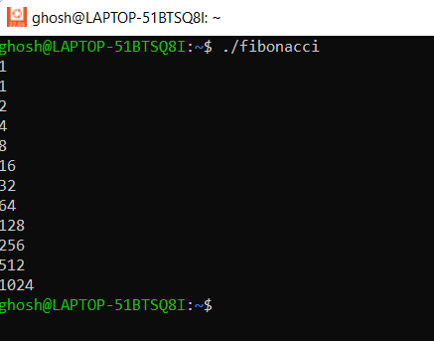

Incorrect Output

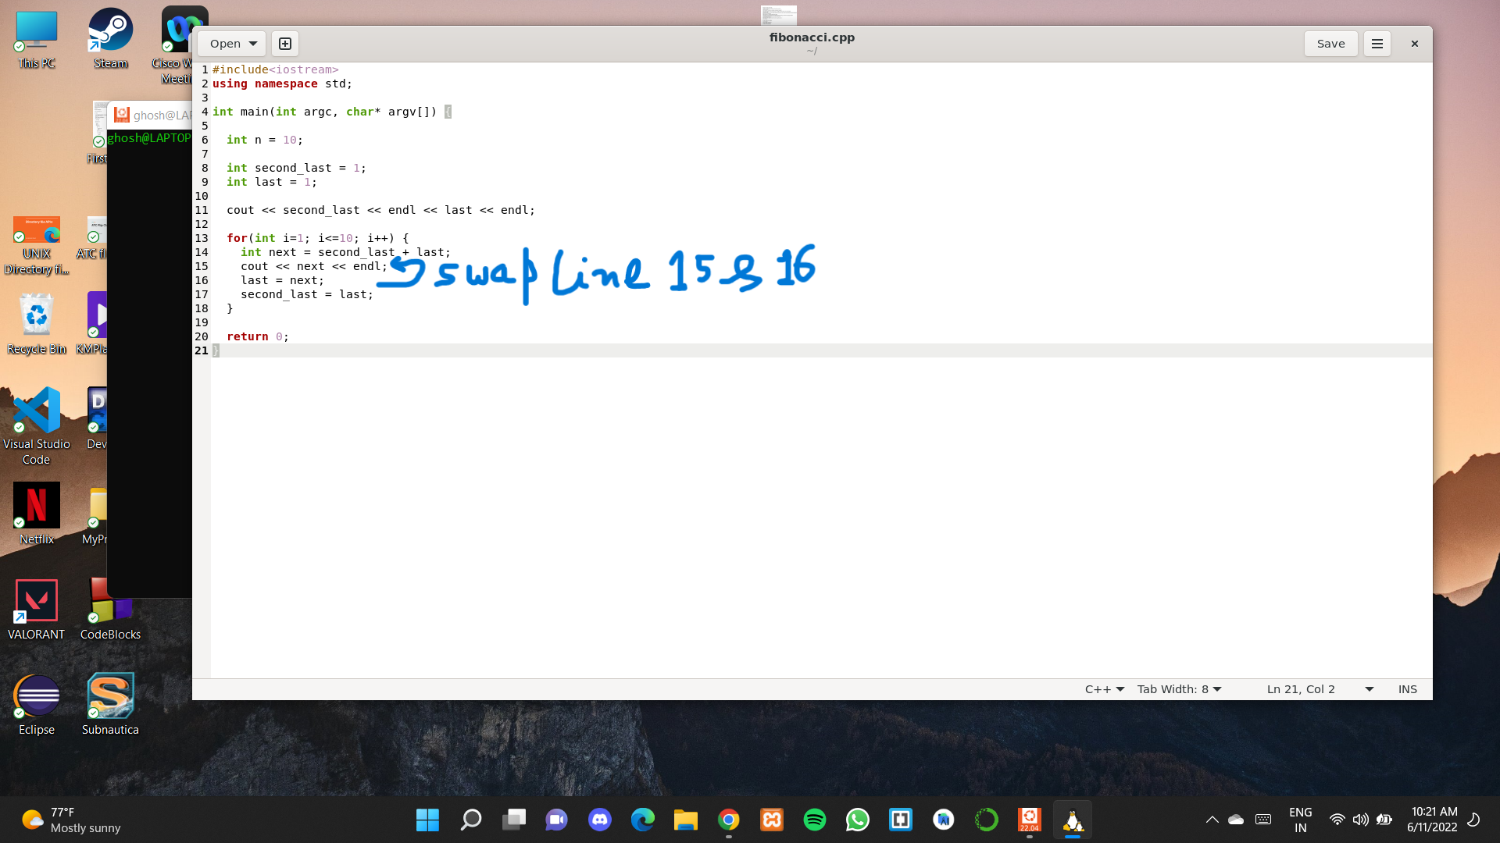

Correction made in Code

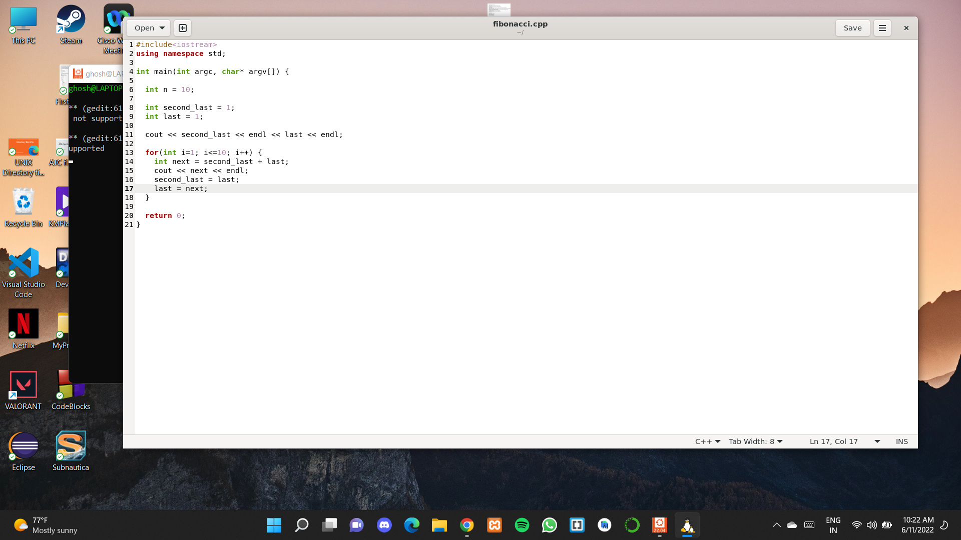

Code after correction

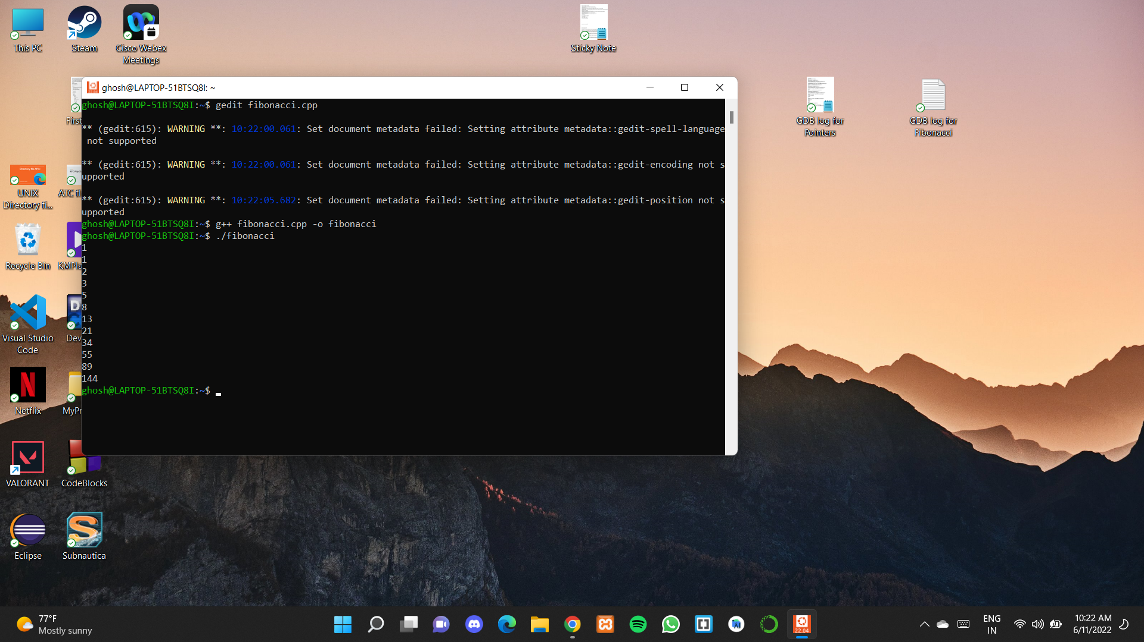

Correct Output

Code for manipulating Pointers:

In this code, we come across a segmentation fault once we run the code. Upon inspection, the error was occurring due to assigning the pointer address to value 0x0, which is not allowed. At memory address 0x0, depending on the machine, we might find RAM, ROM, peripherals, or unmapped space. So upon commenting that line out, our code was corrected and the code executed without any error.

Another solution could have been, in line number 12 of the code where the error is occurring, instead of commenting that line out, we can reverse the assignment and instead of assigning the value p=q, we can write q=p, which will also solve the error.

Below attached are the screenshots of the code before and after error removal:

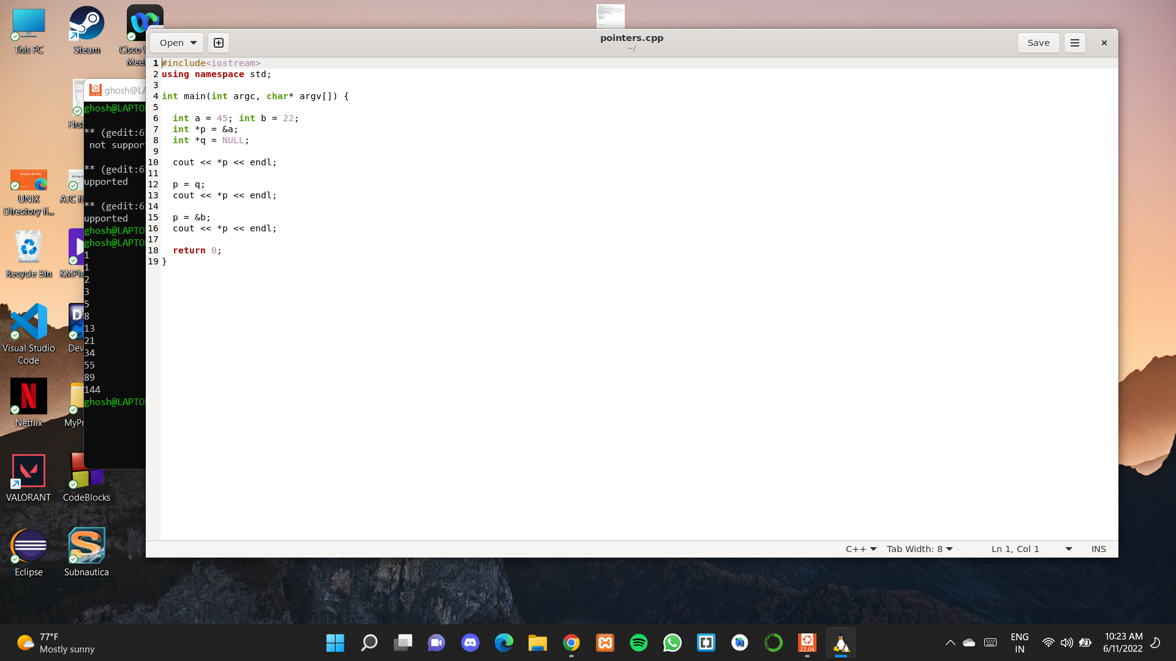

Original code with error

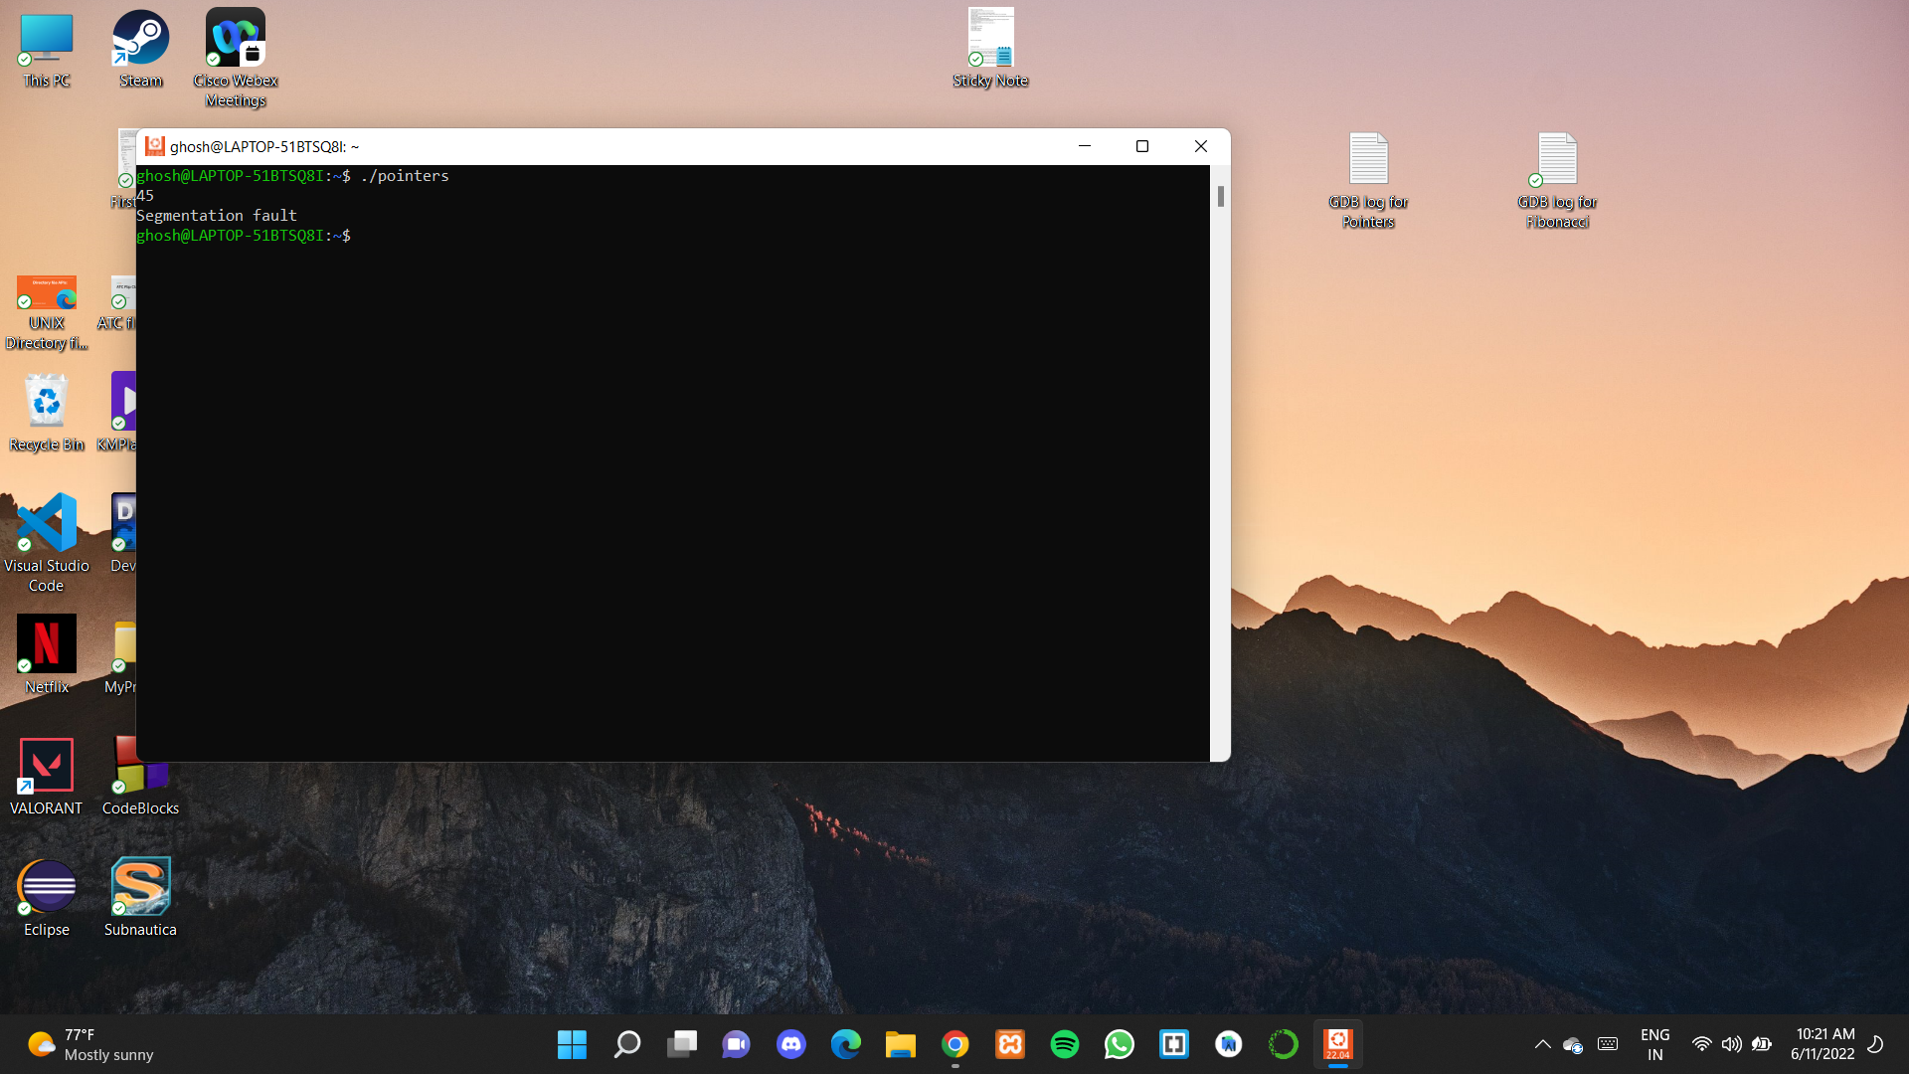

Output with error

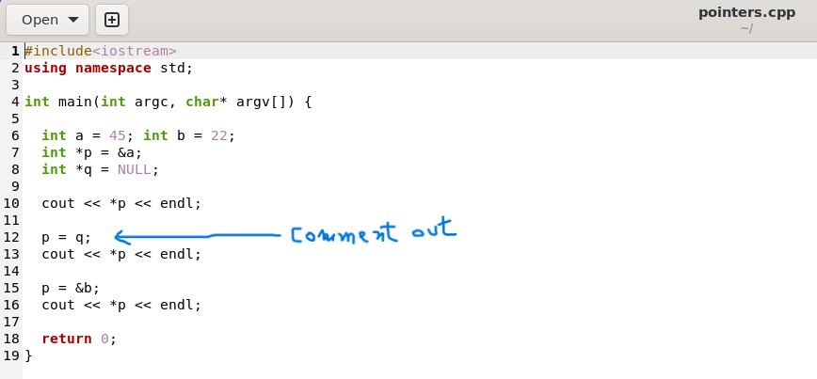

Correction made in code

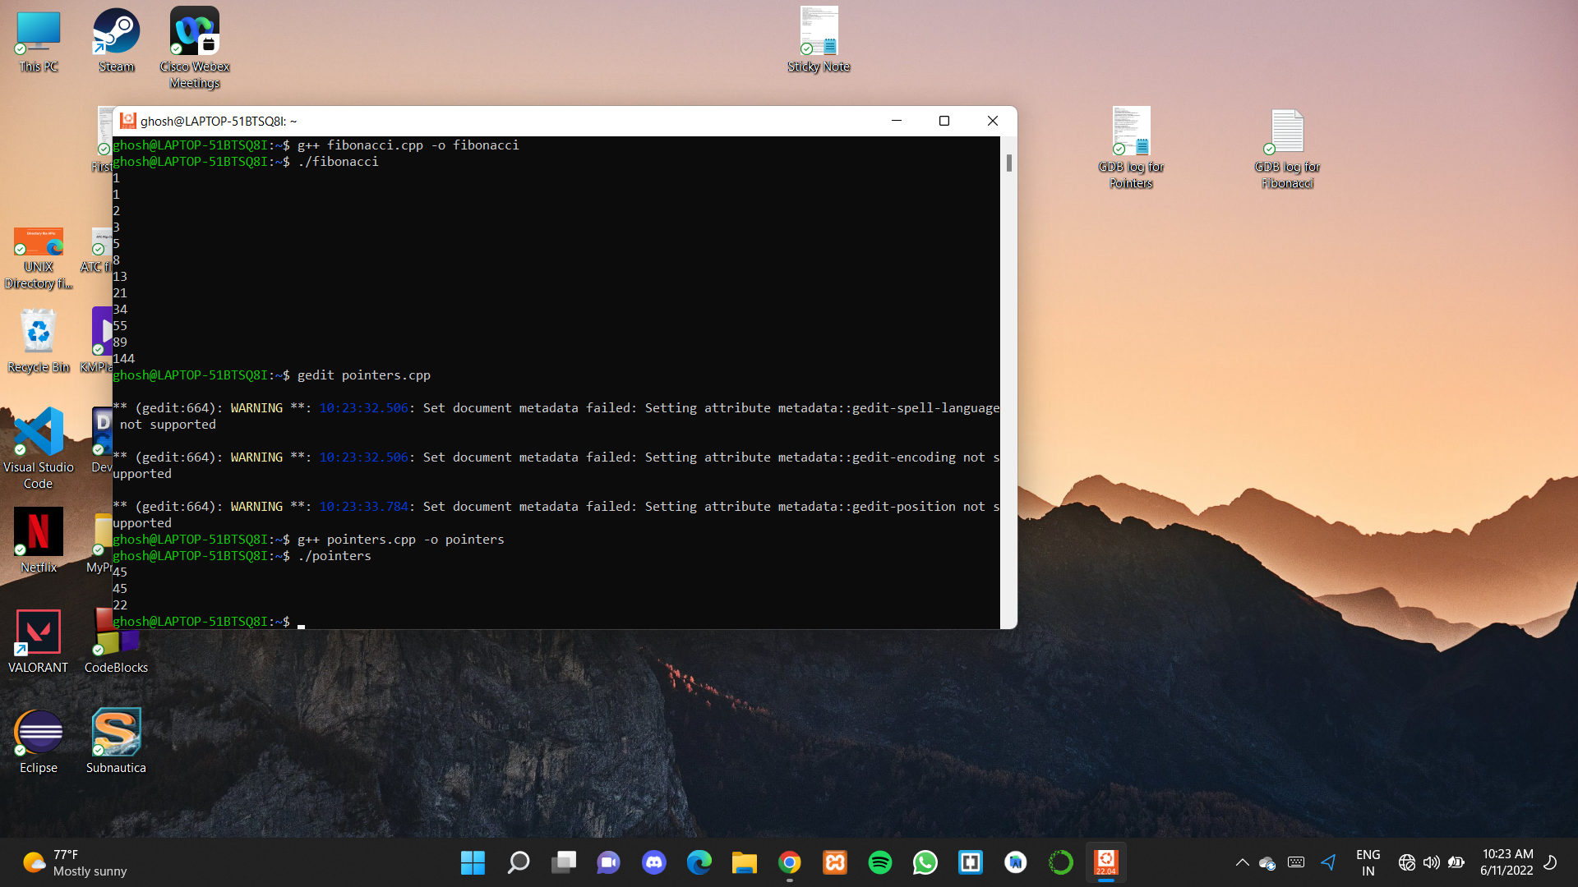

Corrected output